

**CAPSTONE PROJECT REPORT**

**Report 3 – Software Requirement Specification**

– Ho Chi Minh, June 2024–

**Table of Contents**

I. Project Report 3

1. Status Report 3

2. Team Involvements 3

3. Issues/Suggestions 3

II. Software Requirement Specification 4

1. Overall Description 4

1.1 Product Overview 4

1.2 Business Rules 5

2. User Requirements 6

2.1 System Actors 6

2.2 Use Cases 6

3. Functional Requirements 8

3.1 System Functional Overview 8

4. Non-Functional Requirements 11

4.1 External Interfaces 11

4.2 Quality Attributes 12

5. Other Requirements 14

5.1 Appendix1 - Messages List 14

5.2 Appendix2 - … 14

5.3 … 14

# I. Record of Changes

| **Date** | **A* M, D** | **In charge** | **Change Description** |
| --- | --- | --- | --- |
| 18/6/2024 | A |  | Add a Use Case Diagram and Context Diagram |
| 19/6/2024 | A |  | Write part 4 **Non-Functional Requirements** |
| 20/6/2024 | A |  | Write part 2  **User Requirements** |
| 20/6/2024 | A |  | Write part 3 |
| 20/6/2024 |  |  | Write part 5 **Requirement Appendix** |
|  |  |  |  |
|  |  |  |  |
|  |  |  |  |
|  |  |  |  |
|  |  |  |  |
|  |  |  |  |
|  |  |  |  |
|  |  |  |  |

*A - Added M - Modified D - Deleted

# II. Software Requirement Specification

## 1. Product Overview

The Intern Management System (IMS) is an advanced cloud-based platform designed to streamline the entire lifecycle of internship management. It supports scheduling, tailored training programs, real-time performance tracking, and comprehensive analytics. IMS enhances communication and efficiency across all users—HR, coordinators, mentors, and interns—making it an ideal solution for optimising intern productivity and program success in any business.

It supports scheduling, tailored training programs, real-time performance tracking, and comprehensive analytics. These solutions collectively aim to simplify administrative tasks, improve intern engagement and productivity, and ensure the overall success of the internship program.

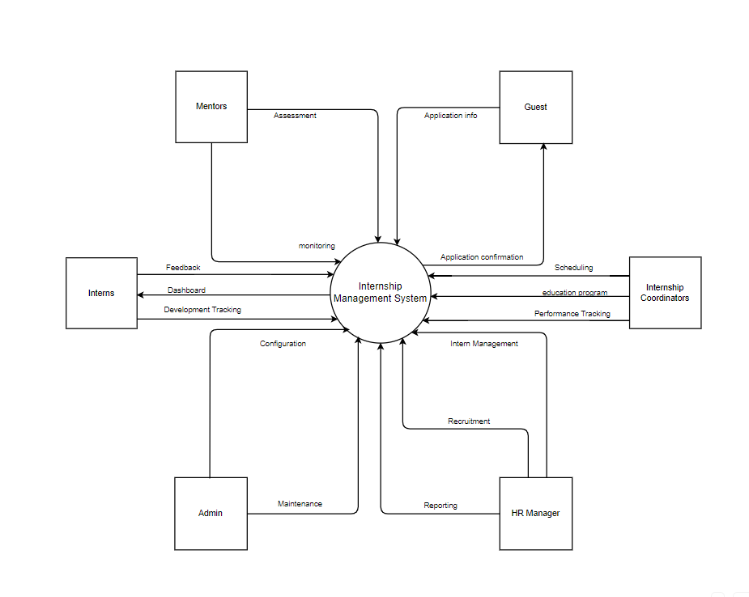

## 2. User Requirements

### 2.1 Actors

*[An actor is a person (or sometimes another software system or a hardware device) that interacts with the system to perform a use case. Following are some questions you might ask to help user representatives identify actors*

* *Who (or what) is notified when something occurs within the system?*
* *Who (or what) provides information or services to the system?*
* *Who (or what) helps the system respond to and complete a task?*

*This part gives the description of system actors, you can follow the table form as below]*

| **#** | **Actor** | **Description** |
| --- | --- | --- |
| 1 | Administrator | •System Configuration and Maintenance: Handle system settings, user permissions, and data security protocols.  • Technical Support: Provide technical support to users and troubleshoot system issues. |
| 2 | HR Manager | • Recruitment Management: Create and manage internship campaigns, from job postings to application collection.  • Intern Profile Management: Maintain a database of intern personal information, educational backgrounds, and work histories with advanced search capabilities.  • Reporting and Analytics: Generate automatic reports on program effectiveness and intern performance. Utilise analytics tools to identify trends and improve processes. |
| 3 | Mentor | • Daily Progress Monitoring: Use the system to log daily activities and provide immediate feedback to interns.  • Skill Assessment: Conduct regular assessments to evaluate intern skills and development needs.  • Communication Tools: Engage in direct communications with interns for guidance and support through integrated messaging systems. |
| 4 | Intern | • Personal Dashboard: Access a personal dashboard to view tasks, schedules, feedback, and educational resources.  • Feedback Submission: Provide feedback on training experiences and mentor interactions to help improve the internship program.  • Skill Development Tracking: Monitor personal skill development and receive automated suggestions for improvement based on performance data. |
| 5 | Internship coordinator | • Interview Scheduling: Automate the scheduling of interviews and send reminders via email or SMS.  • Training Program Setup: Design and implement training programs aligned with specific skill development goals.  •Performance Tracking: Monitor and evaluate interns' work progress using predefined KPIs and regular assessments. |
| 6 | Registered User | • Log in to the system and use the application's features. |
| 7 | Guest | • Apply to internship campaign : Upload CV.  • View internship campaign. |

### 2.2 Use Cases

*[A use case (UC) describes a sequence of interactions between a system and an external actor that results in the actor being able to achieve some outcome of value. The names of use cases are always written in the form of a verb followed by an object. Select strong, descriptive names to make it evident from the name that the use case will deliver something valuable for some user]*

#### 2.2.1 Diagram(s)

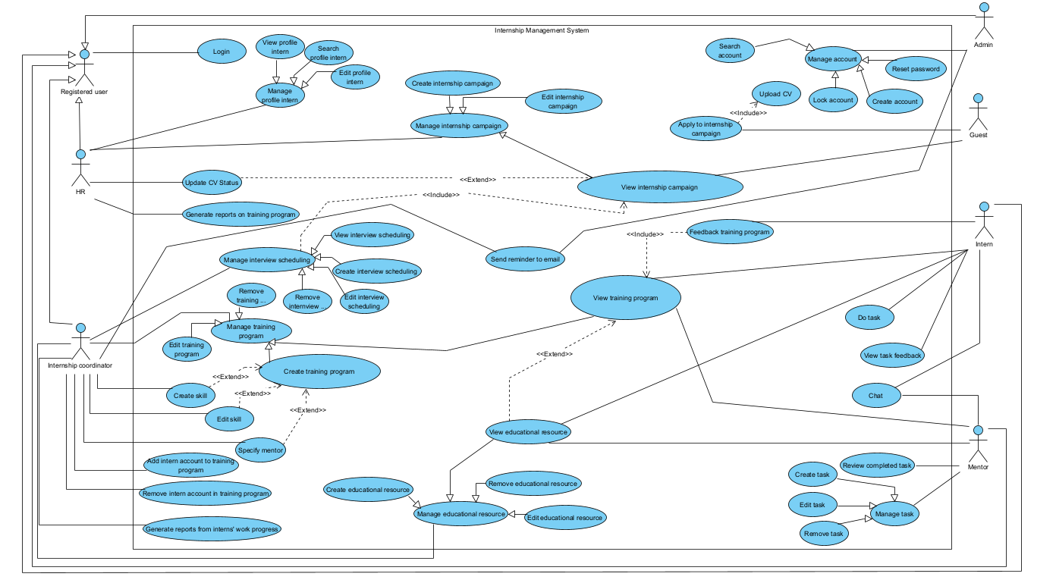

#### 2.2.2 Descriptions

*This part describes the use cases, you can follow the table form as below]*

| **ID** | **Use Case** | **Actors** | **Use Case Description** |
| --- | --- | --- | --- |
| 01 | Manage account | Admin | Manage accounts of multiple users related to the intern management system |
| 02 | Send reminder to email | Admin, Internship coordinator | Send reminder to email |
| 03 | Upload CV Status | HR | Interns upload their CV information for employers to see |
| 04 | Generate report on training program | HR | Generate report on training program |
| 05 | Manage profile intern | HR | Manage intern profiles during the internship campaign |
| 06 | Manage internship campaign | HR | Manage internship campaign |
| 07 | View training program | Mentor, intern | View training program |
| 08 | View educational resource | Mentor, intern | View educational resource |
| 09 | Manage task | Mentor | Manage tasks that interns will have to complete during the internship campaign |
| 10 | Review completed task | Mentor | Review completed task |
| 11 | Chat | Mentor, intern | A place for interns and instructors to discuss the internship campaign |
| 12 | Feedback training program | Intern | Feedback training program |
| 13 | Do task | Intern | Do task |
| 14 | View task feedback | Intern | View task feedback |
| 15 | Manage interview scheduling | Internship coordinator | Manage interview scheduling |
| 16 | Manage training program | Internship coordinator | Manage training program |
| 16 | Create skill | Internship coordinator | Create skills and set goals for interns to complete well |
| 17 | Edit skill | Internship coordinator | Edit skills to suit the campaign for interns to complete |
| 18 | Specify mentor | Internship coordinator | Appoint advisors to guide interns according to each specific course |
| 19 | Add intern account to training program | Internship coordinator | Add intern account to training program |
| 20 | Remove intern account in training program | Internship coordinator | Remove intern account in training program |
| 21 | Generate reports from intern;s work progress | Internship coordinator | Generate reports from intern;s work progress |
| 22 | Manage educational resource | Internship coordinator | Manage educational resource |
| 23 | Login | Registered user | Login to the intern management system |
| 24 | Apply to internship campaign | Guest | Apply to internship campaign |
| 25 | View internship campaign | Guest | View internship campaign |

## 3. Functional Requirements

### 3.1 System Functional Overview

*[Provide functionality overview of software system: screen flow, screen descriptions, system user roles, screen authorization, non-screen functions, ERD]*

#### 3.1.1 Screens Flow

*[This part shows the system screens and the relationship among screens. You can draw the Screens Flow for the system in the form of diagram as below. Please note that beside the normal flat screen, we might have the oval notation for pop-up screen (Import Order) or a screen with multiple information tab (Order Details), etc. You may also use text or background format for different visuality purpose]*

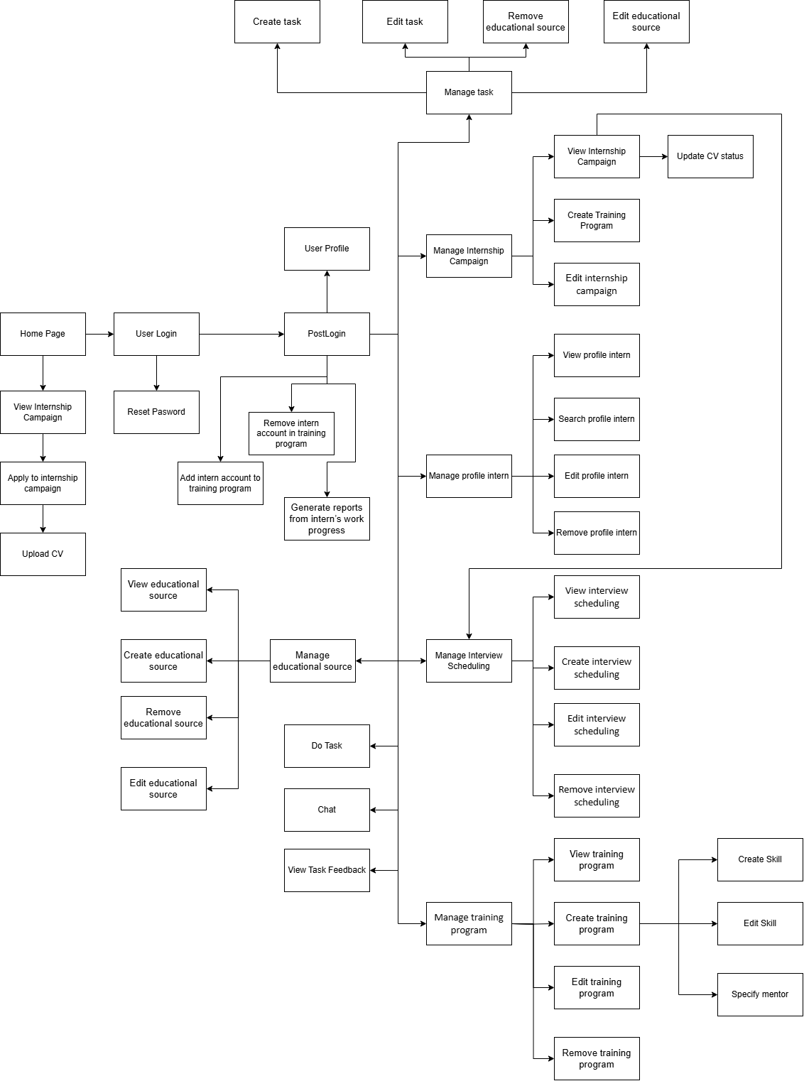

#### 3.1.2 Screen Descriptions

*[Provide the descriptions for the screens in the Screens Flow above]*

| **#** | **Feature** | **Screen** | **Description** |
| --- | --- | --- | --- |
| 1 | Order Meals | Create Order | <<Screen Brief description>> |
| 2 | Order Meals | Change Order |  |
| 3 | .. |  |  |

#### 3.1.3 Screen Authorization

*[Provide the system roles authorization to the system features (down to screens, and event to the screen activities if applicable) in the table form as below – replace Role1, Role2,… with your specific system user role names]*

| **Screen** | **Admin** | **HR Manager** | **Internship Coordinator** | **Mentor** | **Intern** | **Guest** |
| --- | --- | --- | --- | --- | --- | --- |
| Login | X | X | X | X | X |  |
| Manage account | X |  |  |  |  |  |
| Create account | X |  |  |  |  |  |
| Search account | X |  |  |  |  |  |
| Lock account | X |  |  |  |  |  |
| Reset password | X |  |  |  |  |  |
| Manage profile intern |  | X |  |  |  |  |
| View profile intern |  | X |  |  |  |  |
| Search profile intern |  | X |  |  |  |  |
| Edit profile intern |  | X |  |  |  |  |
| Update CV status |  | X |  |  |  |  |
| Manage internship campaign |  | X |  |  |  |  |
| Create internship campaign |  | X |  |  |  |  |
| Edit internship campaign |  | X |  |  |  |  |
| View Internship campaign |  | X | X |  |  | X |
| Generate reports on training program |  | X |  |  |  |  |
| Apply to internship campaign |  |  |  |  |  | X |
| Upload CV |  |  |  |  |  | X |
| Manage interview scheduling |  |  | X |  |  |  |
| View interview scheduling |  |  | X |  |  |  |
| Create interview scheduling |  |  | X |  |  |  |
| Edit interview scheduling |  |  | X |  |  |  |
| Remove interview scheduling |  |  | X |  |  |  |
| Manage training program |  |  | X |  |  |  |
| View training program |  |  | X | X | X |  |
| Create training program |  |  | X |  |  |  |
| Edit training program |  |  | X |  |  |  |
| Remove training program |  |  | X |  |  |  |
| Create skill |  |  | X |  |  |  |
| Edit skill |  |  | X |  |  |  |
| Specify mentor |  |  | X |  |  |  |
| Manage educational source |  |  | X |  |  |  |
| View educational source |  |  | X | X |  |  |
| Create educational source |  |  | X |  |  |  |
| Remove educational source |  |  | X |  |  |  |
| Edit educational source |  |  | X |  |  |  |
| Add intern account to training program |  |  | X |  |  |  |
| Remove intern account in training program |  |  | X |  |  |  |
| Generate reports from intern’s work progress |  |  | X |  |  |  |
| Send reminder |  |  | X |  |  |  |
| Receive reminder |  |  |  |  |  | X |
| Manage task |  |  |  | X |  |  |
| Create task |  |  |  | X |  |  |
| Edit task |  |  |  | X |  |  |
| Remove task |  |  |  | X |  |  |
| Review completed task |  |  |  | X |  |  |
| Do task |  |  |  |  | X |  |
| View task feedback |  |  |  |  | X |  |
| Feedback training program |  |  |  |  | X |  |
| Chat |  |  |  | X | X |  |

#### 3.1.4 Non-Screen Functions

*[Provide the descriptions for the non-screen system functions, i.e batch/cron job, service, API, etc.]*

| **#** | **Feature** | **System Function** | **Description** |
| --- | --- | --- | --- |
| 1 | <<Feature Name>> | <<Function Name1>> | <<Function Name1 Description>> |
| 2 | … |  |  |

#### 3.1.5 Entity Relationship Diagram

*[Provide the entity relationship diagram and the entity descriptions in the table format as below]*

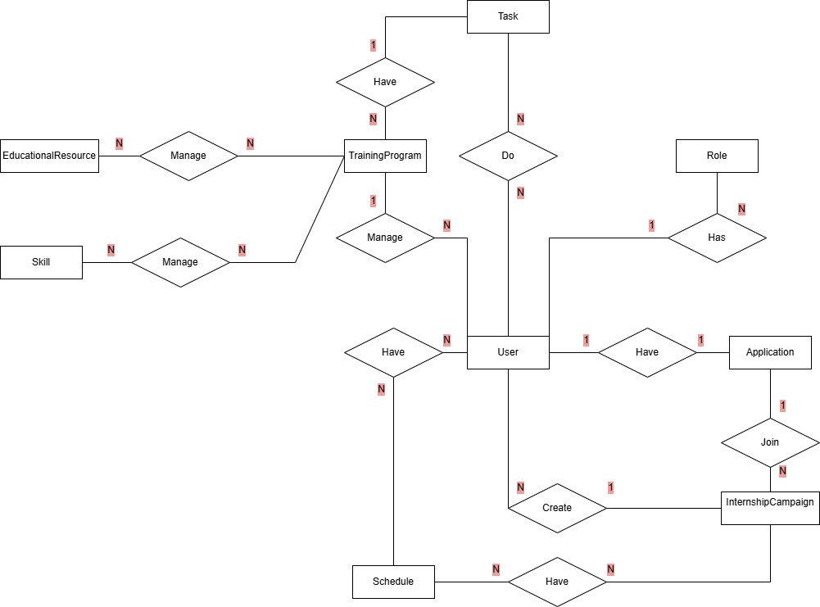

**Entities Description**

| **#** | **Entity** | **Description** |
| --- | --- | --- |
| 1 | Role | Store all roles in the system (Admin, Mentor, HR, Intern,...) |
| 2 | User | Store user information in the system (username, password, personal information,...) |
| 3 | Application | Store information, CV of guest apply to internship campaign |
| 4 | InternshipCampaign | Store all information about the internship campaign (Name, JD, Requirements,...) |
| 5 | Schedule | Store schedules of the internship campaign |
| 6 | TrainingProgram | Store training program in the system (name, description, objectives, mentor manage that training program) |
| 7 | EducationalResource | Store educational resources in each training program |
| 8 | Skill | Store skills that interns can achieve after completing the training program |
| 9 | Task | Store task in the training program is assigned by a mentor that the intern must do |

## 4. Non-Functional Requirements

#### 4.1 External Interfaces

This section ensures that the Intern Management System (IMS) will communicate properly with users and external hardware or software/system elements. Key interface requirements include:

* **User Interface**: The system must provide a web-based interface accessible via major browsers (Chrome, Firefox, Safari, Edge).
* **Email or SMS Services**: The system should integrate with external email or SMS services to send notifications and reminders.
* **Data Export/Import**: The system must support CSV and Excel formats for data import and export to ensure compatibility with external data analysis tools.

#### 4.2 Quality Attributes

This section outlines the required system characteristics (quality attributes).

##### 4.2.1 Usability

* **Training Time**:
  + Normal users (Interns, Mentors) should become proficient within 2 hours of training.
  + Power users (HR Managers, Internship Coordinators, Admin) should become proficient within 4 hours of training.
* **User Interface Standards**:
  + The system should conform to common usability standards such as Microsoft’s GUI standards, ensuring a familiar and intuitive user experience.
* **Accessibility**:
  + The interface must comply with WCAG 2.1 AA standards to ensure accessibility for users with disabilities.
* **Task Efficiency**:
  + Users should be able to complete key tasks (e.g., scheduling interviews, updating profiles) within 2-3 minutes.
* **Consistency**:
  + The system should maintain a consistent look and feel across all modules and screens to reduce the learning curve.

##### 4.2.2 Reliability

* **Availability**:
  + The system must be available 99.95% of the time, allowing for no more than 4.38 hours of downtime per year.
* **Mean Time Between Failures (MTBF)**:
  + The system should have an MTBF of at least 500 hours.
* **Mean Time To Repair (MTTR)**:
  + The system should be repairable within 1 hour of a failure.
* **Data Integrity**:
  + The system must ensure data accuracy with a precision rate of 99.9%.
* **Error Rates**:
  + Critical Bugs: Less than 0.1% of total bugs should result in complete data loss or major functionality loss.
  + Significant Bugs: Less than 1% of total bugs should cause partial data loss or limited functionality.
  + Minor Bugs: Less than 5% of total bugs should be minor or cosmetic issues.

##### 4.2.3 Performance

* **Response Time**:
  + The average response time for any transaction should be less than 2 seconds.
  + Maximum response time for any transaction should not exceed 5 seconds.
* **Throughput**:
  + The system should handle at least 100 transactions per second.
* **Capacity**:
  + The system should support up to 10,000 simultaneous users without performance degradation.
* **Resource Utilisation**:
  + Memory usage should not exceed 75% of available resources during peak times.
  + Disk usage should not exceed 80% of available storage.
  + Network bandwidth utilisation should be optimised to maintain response times under high traffic conditions.

##### 4.2.4 Maintainability

* **Modularity**:
  + The system should be designed with a modular architecture to facilitate easy updates and maintenance.
* **Documentation**:
  + Comprehensive documentation must be provided for system configuration, operation, and maintenance.
* **Scalability**:
  + The system should be scalable to accommodate future growth in the number of users and data volume.

## 5. Requirement Appendix

*[Provide business rules, common requirements, or other extra requirements information here]*

### 5.1 Business Rules

*[Provide common business rules that you must follow. The information can be provided in the table format as the sample below]*

| **ID** | **Rule Definition** |
| --- | --- |
| BR-01 | Internships must be scheduled in blocks of 15 minutes. |
| BR-02 | Internships can only be scheduled between 8:00 A.M. and 6:00 P.M. local time, inclusive. |
| BR-03 | All internships for a single intern must be within the same department. |
| BR-04 | All internship payments must be processed through the same payment method for a single intern. |
| BR-11 | If an internship requires remote participation, the intern must use the company's designated remote work tools. |
| BR-12 | Internship compensation is calculated based on the agreed hourly rate times the number of hours worked, plus applicable taxes. |
| BR-24 | Only HR managers and department supervisors can create, modify, or delete internship records. |
| BR-33 | Network transmissions that involve financial information or personally identifiable information require 256-bit encryption. |
| BR-86 | Only full-time employees can be assigned as mentors for interns. |
| BR-88 | An intern can only be assigned to a mentor if the mentor has no more than three interns under their supervision at the same time. |

### 5.2 Common Requirements

1. User Authentication: The system must support user authentication using secure methods such as OAuth 2.0.

2. Role-Based Access Control: The system must implement role-based access control to restrict access to certain features based on user roles (e.g., Intern, HR Manager, Department Supervisor).

3. Data Backup: The system must perform daily backups of all internship records and related data.

4. Scalability: The system must be able to handle at least 1000 concurrent users without performance degradation.

5. Audit Trail: The system must maintain an audit trail of all changes made to internship records, including the date, time, and user who made the changes.

6. Data Export: The system must allow exporting internship data to CSV and Excel formats.

7. Notifications: The system must send email notifications to interns and supervisors for important events (e.g., internship start date, feedback submission).

### 5.3 Application Messages List

| **#** | **Message code** | **Message Type** | **Context** | **Content** |
| --- | --- | --- | --- | --- |
| 1 | MSG01 | In line | There is not any search result | *No search results.* |
| 2 | MSG02 | In red, under the text box | Input-required fields are empty | *The * field is required.* |
| 3 | MSG03 | Toast message | Updating intern information successfully | *Update intern information successfully.* |
| 4 | MSG04 | Toast message | Adding new intern successfully | *Add intern successfully.* |
| 5 | MSG05 | Toast message | Confirming email of internship assignment sent successfully | *A confirmation email has been sent to {email_address}.* |
| 6 | MSG06 | Toast message | Resetting internship information successfully | *Reset internship information successfully.* |
| 7 | MSG07 | Toast message | Deleting internship information successfully | *Delete internship information successfully.* |
| 8 | MSG08 | In red, under the text box | Input value length > max length | *Exceed max length of {max_length}.* |
| 9 | MSG09 | In line | Username or password is not correct when clicking sign-in | *Username or password is not correct when clicking sign-in* |

### 5.4 Other Requirements…